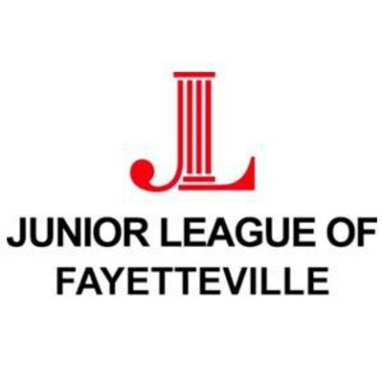

Women building better communities

Community Assistance Program (CAP) Grant
Grant Application

The Junior League of Fayetteville, Inc. is an organization of women committed to promoting voluntarism, developing the potential of women, and improving the community through the effective action and leadership of trained volunteers. Its purpose is exclusively educational and charitable.

The JLF focus area is to strive and assist in the prevention of homelessness, food insecurity, and related concerns affecting children and families in our communities. Requests for capital campaigns, fund raising, salaries, sectarian religious projects, scholarships and long-term funding will not be considered. Taxes are not refundable by the CAP Grant funds.

Application Due Monday, November 15, 2021 before 5:00 p.m.

Applicants will be notified of acceptance or denial by December 31, 2021
Approved applicants must submit receipts and final reports by April 30, 2022

The following items must accompany the CAP Grant Application:

- IRS letter recognizing nonprofit exemption status
- Detailed project budget (itemized break down of how funds will be spent)
- Estimates for work to be secured (at least three (3) if applicable)
- Any brochures or additional information you have about your organization
- List of the Board of the Directors
- Answers to the items on the following pages

Please answer the following questions:
- Title of Project:
- Name of applicant organization
  - Address:

  - Telephone number:
  - Email address:
  - Website (if applicable):
- Contact person for information concerning this proposal
  - Name:
  - Title:
  - Telephone number:
  - Email address:
- Date of Application:
- What is the purpose of your organization?

- How long has your organization been in operation?

- Has the Junior League of Fayetteville funded your organization in the past?
(If your organization has received funding consecutively in the last 3 years-you are not eligible for a 4th year)

  - If “yes,” when?
  - For what purpose?

- Exact amount currently requested from the Junior League of Fayetteville:

- Total cost of the project/service:
- Other sources of funding (if applicable):

- Anticipated start date of project:
- How is the focus area of the Junior League addressed in your project?:

- Purpose of the project must include how your organization will market and promote the Junior League of Fayetteville :

- What are some volunteer opportunities for the Junior League of Fayetteville to partner with you on the proposed project/service?

- Briefly state the need for funding: Provide at least three (3) estimates obtained for any work associated with this request?

- Are the estimates attached to this application, if applicable?

- How did you learn about the availability of the funds associated with the JLF CAP Grant?

- Is this a Pilot Program? If “yes,” where do you plan to seek future funding?

- Is your 501(c)(3) letter attached?

- Is your breakdown of how the funds will be spent attached or listed in the application?
- Other Comments

_________________________________ ______________________________
Printed Name and Title of Requestor Signature of Requestor

_________________________________ ______________________________
Printed Name of Project Director Signature of Project Director

Submit Grant Application to:

Due to the Coronavirus (COVID-19) pandemic, it is highly encouraged that applications are submitted electronically via email or the JLF website. If sending electronic files, JLF will send a confirmation of receipt.

Email to: info@jlfay.org and capgrants@jlfay.org

or

Upload on the Junior League website

or

Junior League of Fayetteville
Attn: CAP Grants
2605 Fort Bragg Road
Fayetteville, NC 28303-4718

Note: In Accordance with Junior League of Fayetteville Policy dated March 2017
Policy IX. Grant Programs, A. Community Assistance Program (CAP) Grants
An applicant may submit an application once per year, and become a recipient for three consecutive years. However, the applicant must refrain from submitting an application the year immediately following the three year period.

All property or material purchased from the CAP Grant funding will display the Junior League of Fayetteville logo.

